Tasmanian Adult Literacy Action Plan Annual Report 2014-15
Department of Education
LINC Tasmania

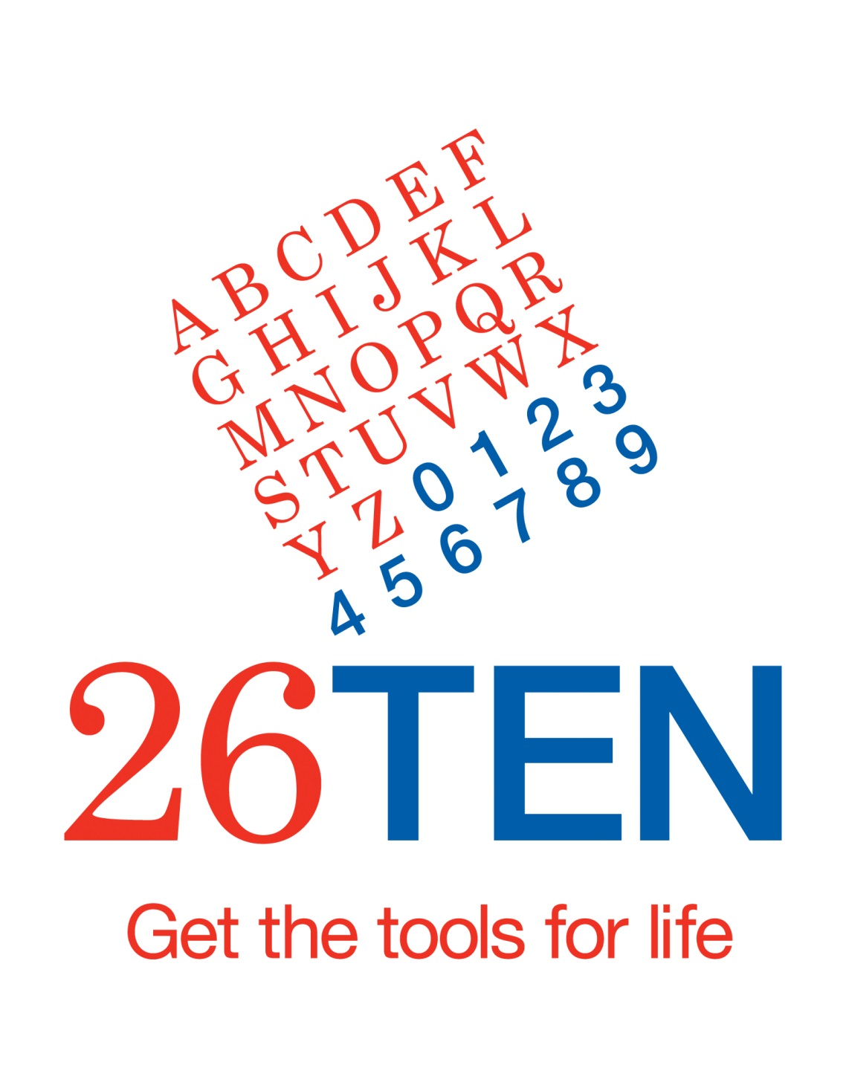
July 2015
File: DOC/15/167616

Introduction
The Tasmanian Adult Literacy Action Plan (the Plan) achieved concrete positive outcomes for adult Tasmanians, business and the economy in its fifth year of implementation. All major actions of the Plan have now been implemented, and are either completed or ongoing.
To ensure a sound basis for efforts beyond 2015, work in 2015 drew on what we had learnt to make recommendations for future directions. A new strategy for 26TEN is being developed. It will build on the foundations laid through implementation of the Plan and provide a framework for collective action by the whole state to raise adult literacy and numeracy levels and promote clear communication.
LINC Tasmania had full responsibility for the Plan in 2014-15, following the move of Skills Tasmania to the Department of State Growth from 1 July 2014.

Strategy 1: An informal community and workplace network of adult literacy support
26TEN kept people talking about adult literacy
Raising community awareness and encouraging organisations and individuals to work together to improve adult literacy in Tasmania continued to be a strong focus for 26TEN in 2014-15. 26TEN, managed and supported from within LINC Tasmania, reviewed and revised the members program, after its initial year of operation, and introduced a simpler and more effective membership package. New members were recruited from a range of sectors. The successful plain English and literacy awareness workshops were further enhanced, and train-the-trainer workshops were developed to expand the capacity of 26TEN to deliver literacy awareness. The 26TEN Steps awareness training package was launched in October 2014 and literacy awareness workshops were held across the state.
The 26TEN Coalition, a group of community members committed to championing the cause of adult literacy in Tasmania, continued to support this work by raising awareness and encouraging action in key sectors. In 2014-15, the Coalition established a regular health sector meeting focused on literacy and a plan of action for the construction sector and began to make strong progress in both these areas.
The focus for 26TEN week in 2014 was “Read it, Write it, Make it count”. A range of activities were held, with a strong focus on numeracy.
Traffic to the 26TEN Facebook page began to increase in 2014-15 and the number of visits to the 26TEN website also continued to grow steadily. Although this activity and feedback during outreach suggested people were talking about adult literacy and numeracy, a 26TEN awareness survey carried out in March 2015 showed that the number of Tasmanians aware of the challenge of adult literacy and numeracy and of 26TEN remained low. These results have informed work on a new communications strategy to be launched in 2015-16.
We supported the adult literacy workforce
In 2014-15, 26TEN launched the Year of numeracy for adult literacy practitioners and supported a comprehensive program of professional development focused on helping adults raise their numeracy levels. This was in recognition of the statistics showing low adult numeracy skill levels, and the community perception that “it’s ok to be poor at maths”. This contrasts with research showing the direct correlation between numeracy skills and income and other life opportunities.
26TEN grants supported the efforts of business
LINC Tasmania took on responsibility for grants administration from July 2014. In 2014-15, a total of $446,518 was awarded through 11 grants to employers. Recipients were located across the state, from beyond Smithton (Van Diemen’s Land Company) to Cambridge (Houston’s Farm). There were four projects in the north, two in the south and five with a state-wide focus. Grants were awarded to make workplace documentation more accessible and to develop the ability of employees to write plain English documents, to build the employees’ literacy and numeracy skills, and for a combination of both.
The agriculture and food production sectors were well-represented. Primary Employers Tasmania received a grant to develop a set of common operating procedures for primary producers. Houston’s Farm is improving the literacy and numeracy skills of employees in the processing, farm and administration sections. Other recipients in this sector include the Tasmanian Beekeepers Association, Harvest Moon, JBS Meats and J Boags and Son.
In addition to Primary Employers Tasmania, two other peak industry bodies were awarded grants. These organisations are well placed to bring about widespread changes of attitudes and improvements in literacy and numeracy. National Disability Services Tasmania was awarded a grant to implement the Tasmanian Disability Sector Language Literacy and Numeracy Action Plan, including providing workplace training to all member organisations. Aged and Community Services is working to put literacy and numeracy resources for the sector online.
26TEN grants helped build communities
Seven community grants were awarded in 2014-15 to a total of $202,574. Grants were awarded to seed 26TEN communities, build literacy and numeracy skills within communities, and to develop resources.
The Derwent Valley and the Huon Valley have joined Burnie and Circular Head to become 26TEN Communities in which everyone knows about adult literacy, everyone is supported and everyone communicates clearly.
Ability Employment and TasTAFE received a grant to develop customised workplace safety training programs and resources to meet the specific literacy and numeracy needs of people with intellectual disabilities. In another partnership, TasTAFE and the Northern Suburbs Community Centre are running programs to prepare people for training.
Other grants will allow sets of popular basic readers to be brought up to date and made available online, and publish new student work.
We began to promote clear communication
In 2014-15, 26TEN launched a Guide to Plain English, developed in cooperation with the Local Government Association of Tasmania. 26TEN continued to provide Plain English workshops throughout the State, further refining the workshop model in response to feedback, and beginning work to renew its register of plain English training providers.
26TEN held a forum on plain English addressed by the Secretary of the Department of Premier and Cabinet. It provided high-level plain English training to select LINC Tasmania staff aimed at developing plain English expertise within the organisation to enable it to provide a best practice example. Several staff of 26TEN member organisations also participated. It also supported the Department of Premier and Cabinet to train core groups of plain English experts. This followed a successful pilot project by the Department of Premier and Cabinet which was a first step to rolling out plain English across its various service areas and playing a lead role in promoting plain English in the state sector.
A number of 26TEN members became active promoters of plain English. The Department of Health and Human Services continued its strong work on revising health documentation for the Tasmanian public and promoting health literacy for all Tasmanians. 26TEN grant recipients ran successful projects improving the clarity and accessibility of workplace documents.

Strategy 2: A state-wide team of coordinators and trained volunteers to drive the Adult Literacy Network
The LINC Literacy Network provide high quality assistance to more people
In 2014-15, the number of adult Tasmanians receiving support through the LINC Tasmania network reached 2,252. The number of volunteer tutors recruited and trained since the launch of the network reached 1,131, with 481 of these active in 2014-15.
In 2014-15, LINC Tasmania reviewed the Literacy Skills Development Program and introduced simpler administrative processes to make the program more effective. In 2014-15, 38 projects were undertaken, providing embedded literacy support to meet the specific needs of communities and target groups with positive outcomes.
Literacy support provided through LINC Tasmania allowed people to improve their skills and engage more fully with family, community and work. 177 clients increased at least one level on the Australian Core Skills Framework (ACSF) (a 12% increase over 2013-14), 301 clients commenced further education and training (a 103% increase on 2013-14), and 64 clients commenced paid employment (a 68% increase on 2013-14).
A survey of 408 former and current LINC literacy clients undertaken by Enterprise Marketing Research Services (EMRS) from 28 May to 6 June 2015 showed strong levels of satisfaction with the service. Survey responses showed that the literacy service was meeting community needs, building strong relationships and supporting literacy skills development with positive outcomes for individuals and communities.
96% of respondents were satisfied to some degree with their experience. 74% were ‘very satisfied’. The two most common reasons for being satisfied were ‘skills improved/ achieved goals’ (35%) and ‘people friendly/ supportive/ helpful’ (34%). The majority of respondents agreed at some level that they were ‘more confident and positive’ (95%) as a result of participating in the program.

Strategy 3: Developing key indicators to measure improvements in adult literacy outcomes
We refined new ways to measure outcomes for clients
2014-15 saw the completion of projects begun in 2013-14 aimed at improving measurement of client outcomes. LINC Tasmania considered recommendations from work on measuring clients’ self-reported confidence and initiated a six month trial of the ‘catching confidence’ measurement tool across the LINC Literacy network. This trial will conclude in September 2015. Based on the results of the trial, LINC Tasmania will finalise a tool to consistently and effectively measure changes to a learner’s confidence as a result of participation in literacy programs.
LINC Tasmania completed a project trialling data analysis software to make better use of qualitative data. The project recommended changes to the way data is captured to ensure more suitable qualitative data is available. These changes are being made as the opportunity arises. A related trial of the use of video interviews with clients is still underway and will be completed in 2015-16.
Stages 1 and 2 of a broad-reaching project looking at robust ways to measure and recognise improvements in literacy skills within a single level in the ACSF, were completed in 2014-15 (with the report of Stage 2 to be completed in 2015-16). Stage 1 recommended trials of various finer grained measures. Stage 2, the implementation of these trials, involved 11 projects across the state in community and workplace settings. LINC Tasmania used the preliminary results of these trials to develop an approach to measuring improvement of skills within a single level of the ACSF, which will be implemented as a six-month trial from the start of 2015-16. The work has received strong national interest and positive response. It will improve our ability to show increases in learner skills when the literacy intervention is short-term and workplace-based, or for a learner with very low level skills.
We improved our data management
To support these projects, LINC Tasmania made ongoing improvements to the software used to manage data and provided extensive training to those throughout the literacy network who enter the data. These changes have resulted in improved data integrity.

Summary of Implementation

Strategy | Action | Description | Status June 2015
1 | 1.1 | An Adult Literacy Investment Fund will be established. This fund will provide $1 million a year over four years to fund programs in workplaces and communities. | Established  Funding extended in forward estimates to 2017
 | 1.2 | Establish a community of practice for adult literacy workers and volunteers | Established  Continues to be developed
 | 1.3 | Provide additional literacy support to apprentices and trainees | Now part of Skills Tasmania purchasing agreements
 | 1.4 | Further collaboration with the Australian Government on Adult Literacy | Engagement continues to occur where opportunities arise  The Australian Department of Industry’s Australian Core Skills Framework continues to form the basis for assessment of literacy levels in LINC Tasmania programs  LINC Tasmania staff have been engaged in the Australian Government-funded Foundation Skills Assessment Tool development project  LINC Tasmania’s work on finer-grained assessments using the Australian Core Skills Framework is receiving national attention
 | 1.5 | Provide diversity training for frontline service staff | Ongoing  Training provided to all LINC staff  Project underway looking at appropriate training for Centrelink staff
 | 1.6 | Raise community awareness of adult literacy | 26TEN established in 2012  26TEN programs continue to expand
 | 1.7 | Plain language will be promoted | Ongoing  26TEN Plain English guide released in October 2014  Delivery of Plain English workshops throughout the state continues  26TEN working with member organisations  26TEN supporting pilot project in Department of Premier and Cabinet
2 | 2.1 | Extend the Adult Literacy Coordinator Network throughout the state | Network of 23 Literacy Coordinators established in LINC Tasmania and three Department of Justice sites  Over 1131 volunteer literacy tutors recruited and trained  Professional development ongoing
 | 2.2 | Increase literacy support available to inmates of the Tasmania Prison Service (TPS) | Literacy Coordinator providing support in Risdon Prison since 2011  New model for delivery of literacy services in Risdon developed and implemented in 2014 in cooperation with TasTAFE and Tasmanian Prison Service
3 | 3.1 | Consistently and transparently measure progress on improving adult literacy against meaningful indicators | Ongoing  Measures refined throughout 2014  Project to establish finer grained measures for improvement of literacy skills against the ACSF nearing completion  Projects looking at measurement of achievement of personal goals, measurement of confidence and self-esteem, and more effective use of qualitative data completed in 2014-15 and now informing data collection and analysis

Outcomes
 | Outcome | Measure |  | 2010-11 | 2011-12 |  | 2012-13 | 2013-14 | 2014-15 | TOTAL
 | Increased number of adult Tasmanians receiving literacy support (one to one or group) | Number of adults receiving literacy  support in the:
 |  | - 26TEN Grants Program – Employer Stream |  |  |  | 310 | 965 | 929 | NYA | 2204
 |  | - 26TEN Grants Program – Community Stream |  |  |  | 108 | 255 | 323 | NYA | 686
 |  | - Individually tailored support through LINC Tasmania |  |  |  | 988 | 863 | 1391 | 1909 | NA
 |  | - Group support through Literacy Skills Development Programs |  |  |  | 439 | 1006 | 488 | 343 | NA⁶
 |  | TOTAL | 500 |  |  | 1845 | 3089 | 3131 | NA | NA
 | Increased number of adult literacy projects funded | Number of projects funded by the:
 |  | - 26TEN Grants Program - Employers | 6 |  |  | 6 | 10 | 10 | 11 | 43
 |  | - 26TEN Grants Program - Community | 12 |  |  | 11 | 19 | 0 | 7 | 49
 |  | - LINC Tasmania Literacy Skills Development Program | 17 |  |  | 46 | 63 | 45 | 38 | 209
 |  | TOTAL | 35 |  |  | 63 | 92 | 55 | 56 | 301
 | Increased literacy levels of program participants | Number of clients increasing one level on the Australian Core Skills Framework:
 |  | - 26TEN Grants Program – Employers |  |  |  | 42 | 40 | 22 | NYA | 104
 |  | - 26TEN Grants Program - Community |  |  |  | 55 | 39 | 100 | NYA | 194
 |  | - LINC Tasmania Literacy Services |  |  |  | 239 | 193 | 158 | 177 | 767
 |  | TOTAL | 140 |  |  | 336 | 272 | 280 | 177 | 1205

 | Outcome | Measure | 2010 –  11 | 2011-12 | 2012-13 | 2013-14 | 2014-15 | TOTAL
 | Increased levels of participation in education and training by program participants | Number of clients moving on to other education and training programs within three months of receiving support | 66 | 134 | 206 | 144 | 301 | 851
 | Increased employment outcomes for program participants | Number of clients gaining employment within three months of receiving support | 69 | 106 | 97 | 38 | 64 | 374
 | Increased confidence and self-esteem levels of program participants | Number of literacy program participants demonstrating increased confidence and self-esteem | Collection began in 2012-13 |  | 121 | 51 | NA ¹¹ | 172
 | Increased number of trained volunteers with the capacity to provide literacy support to adult Tasmanians | Number of trained literacy volunteers registered with LINC Tasmania | 394 | 529 | 684 | 940 | 1131 | 1131
 | Increased number of apprentices and trainees assisted with literacy and numeracy support | Number of apprentices and trainees accessing additional literacy and numeracy support | 201 | 120 | 124 | 103 | NA | 548
 | Three Adult Literacy Coordinators working with the Department of Justice to provide support and training to prisoners and offenders serving community orders | Number of prisoners and offenders receiving literacy support | Collection began in 2011-12 | 283 | 87 | 90 | 222 | NA

Figures do not include 1 project yet to complete closing report.
Figures do not include 2 projects yet to complete closing reports.
Figures do not include 2 projects yet to complete closing report.
Figures do not include 4 projects yet to complete closing reports.
Figure comprises 993 registered literacy clients and 916 people who received targeted literacy support
Cumulative figure not available as some clients continue across financial years.
Due to the timing of the state election in 2014, the $100,000 allocated to the Community stream was held over to 2014-15.
Figures do not include improvements made by clients of 26TEN Grants Programs previously administered by Skills Tasmania as this data is not available.
A further 12 clients commenced volunteer or unpaid work during this period.
A further 13 clients commenced volunteer or unpaid work during this period.
Collection methods have been inconsistent. Data was not collected in 2014-15 while the measure was reviewed. A new measure self-reported confidence increase will be collected in 2015-16.
Cumulative total.
2012-13 saw periods of prolonged leave and vacancy in the Community Corrections North and South positions which affected client numbers.
The Community Corrections North/North West position was re-established in the second half of 2013-14. Services offered to Risdon Prison were reduced in the second half of 2013-14 as the model was reviewed and refined to align with the transition of prison education to TasTAFE and refine procedures around the use of volunteers in the prison. This figure comprises active and occasional clients from 2013-14 onwards,
Cumulative figure not available as some clients continue across financial year.

