**To:**

**For:**

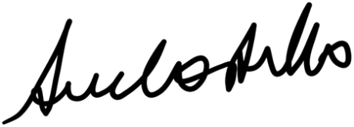

***Sue Costello, Manager, 26TEN***

**26 – 31 October 2020**