26TEN Week photo competition
‘Times have changed!’
Win an Apple Watch Sport 38mm!
Computers, iPads, smart phones and apps have changed our lives. Send us a photo of the way you used to do everyday things before digital technology and a photo of the way you do them now.
The funniest entry and the most interesting entry will each win a prize.
Submit original before and after photos
Census 2011 Census 2016
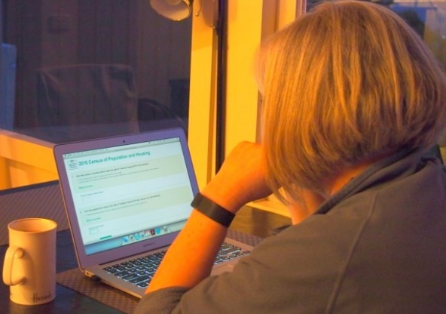
To enter
Collect an entry form from your local LINC or download from our website www.26ten.tas.gov.au
Submit your before and after photos with titles AND entry form in one of the following ways:
- post to the 26TEN Facebook page www.facebook.com/26TENTasmania
- email to email@26ten.tas.gov.au
- put on a USB key and:
  - drop into a LINC, or
  - mail to 26TEN Team, GPO Box 623, Hobart TAS 7001

Need help entering? Ask a LINC staff member!
Key dates
- Entries close 5 pm Sunday 30 October 2016
- Winners will be announced Tuesday 15 November 2016

26TEN ‘Times have changed!’ competition
Entry form
Name
Address
Email
Phone
Photo titles
Are you a LINC employee? Yes ☐ No ☐ |  | Sorry, LINC staff are not eligible for the watches, but the best 3 will win a USB and bragging rights!
By ticking the box I acknowledge that I have permission from all people photographed in my entry to share their image. ☐

Terms and conditions
- Entries must show in a funny or interesting way how digital technology has changed how we do things eg listen to music, correspond etc.
- Entries must be the original work of the entrant and not previously used or published elsewhere other than for personal use.
- A completed entry form must be submitted for each pair of photographs entered.
- Entries must be received no later than 5 pm Sunday 30 October 2016.
- 26TEN will not accept liability for lost entries.
- Winners will be announced on Tuesday 15 November 2016. The prize pool is 2 Apple Watch Sport 38mm and 12 8GB USBs.
- Winners announced on Facebook: www.facebook.com/26TENtasmania and 26TEN website www.26TEN.tas.gov.au.Winners will also be notified by email or phone.
- Photos should be in JPEG (.jpg) digital format and must be at least 300 dpi resolution.
- 26TEN reserves the right to showcase submitted photos on LINC Online, the 26TEN website and Facebook page. 26TEN also reserves the right to use photos in future 26TEN media and marketing.
- Entries cannot be used if they contain material from copyrighted sources.
- Prizes cannot be redeemed for cash.
- An independent judge will select the winning photos. Their decision is final and no correspondence will be entered into.
- Entries received after the deadline will not be accepted.
- Competition is open to all ages.
- Entrants need to be living in Tasmania during the competition period.
- LINC staff are not eligible to win the Apple Watch Sport.
Any questions? Email email@26ten.tas.gov.au
I acknowledge that I have read and accepted the 26TEN Week ‘Times have changed!’ competition terms and conditions.

Signature: _________________________________________ Date:______________

