Tasmanian Adult Literacy Action Plan Annual Report 2013-14

July 2014
File: DOC/15/167000

Department of Education
LINC Tasmania

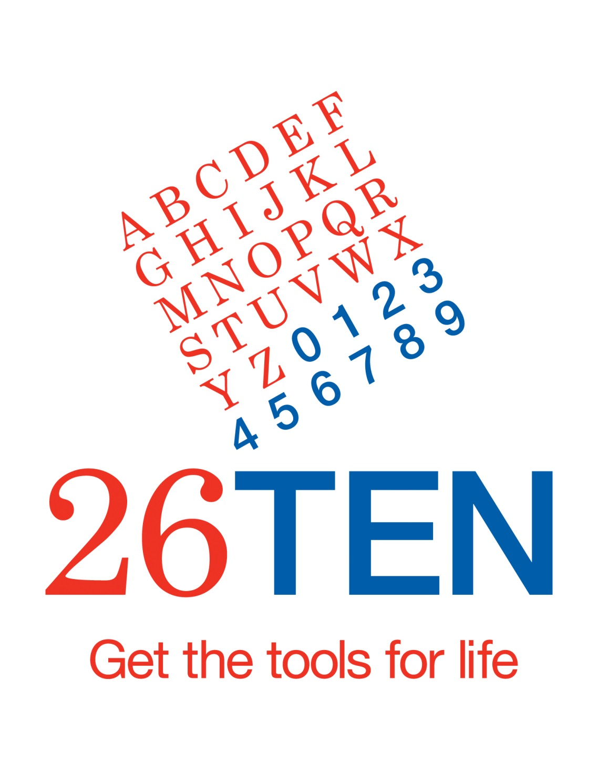

Introduction
The Tasmanian Adult Literacy Action Plan (the Plan) achieved concrete positive outcomes for adult Tasmanians, business and the economy in its fourth year of implementation. All major actions of the Plan have now been implemented, and are either completed or ongoing.
Consolidation, review, and reassessment of measures and goals were important priorities in 2013-14. Work in 2015 will draw on what we have learnt to set a framework for future directions.
In 2013–14, LINC Tasmania shared responsibility for the implementation of the Plan with Skills Tasmania. LINC Tasmania’s responsibilities included the delivery of literacy services, promotion of broad community awareness and action through 26TEN, and measurement of success. Skills Tasmania was responsible for the 26TEN grants, adult literacy workforce development, and reporting against the Plan.
Following the move of Skills Tasmania to the Department of State Growth from 1 July 2014, full responsibility for the Action Plan will be transferred to LINC Tasmania from that date.

Strategy 1: An informal community and workplace network of adult literacy support
26TEN got people talking about adult literacy
26TEN was launched in October 2012 as the major outcome of Strategy 1. In 2013–14, 26TEN began to raise community awareness and encourage organisations and individuals to work together to improve adult literacy in Tasmania.
26TEN, managed and supported from within LINC Tasmania, was developed to include a members’ programme, literacy awareness and plain English workshops, a grants programme (administered by Skills Tasmania in 2013-14), a website, and a 1300 telephone service.
The 26TEN Coalition, a group of community members committed to championing the cause of adult literacy in Tasmania, supported this work. In 2013-14, the Coalition developed a sectoral approach to raising awareness of the issue and encouraging action. Members were particularly active in the health, construction and local government sectors.
26TEN Week, marking the first anniversary of 26TEN, was celebrated across Tasmania in October 2013. Business, community and government organisations held local events with the theme “flying the colours” of 26TEN. Events ranged from small morning teas, to mini 26TEN skills expos. The late Governor, His Excellency Peter Underwood AC, formally recognised the contribution of LINC Tasmania and Skills Tasmania staff, volunteers and learners and 26TEN member organisations, during an event at Government House.
Feedback from literacy awareness workshops and other outreach suggests more Tasmanians now know that many adults need assistance. More people are also becoming aware of how to help others and how to get help. In the 2013-14 financial year, the number of visits to the 26TEN website continued to grow steadily, with an 18% increase in the final quarter over the same period in 2012-13.

We supported the adult literacy workforce
In 2013-14, Skills Tasmania and LINC Tasmania worked together to deliver professional workshops for literacy practitioners, focused on use of the Australian Core Skills Framework. We used the 26TEN Facebook page to share literacy resources. We strengthened links with the Tasmanian and Australian Councils for Adult Literacy, and international practitioners and policy makers.
26TEN grants supported the efforts of business
The 26TEN Grants program, administered by Skills Tasmania in 2013-14, focused the full $500,000 on the Employer Stream, supporting projects to improve workplace literacy. LINC Tasmania will take on responsibility for grants administration from 2014-15.
26TEN awarded grants to a range of employers, including to Treloar Transport and Paneltec to improve safe work procedures and train staff in how to produce high quality, readable documents, to Lion the Heritage to meet the literacy and numeracy needs of a major manufacturing change process, to the Glenorchy City Council to build the skills of the Works and Services Team, and to Mersey Community Care Association to develop the literacy and numeracy skills of their employees and volunteers.
Feedback was very positive with most employers highly satisfied. Employers reported noticeable and positive changes in employees’ skills and attitudes to work. These included more effective meetings, clearer and concise emails, better reporting, increased comprehension of procedures. All of these improvements save time and increased productivity for the grant recipients.
And from employees themselves:
‘Developing spelling skills makes me feel good within myself, and I feel smarter, like I am getting somewhere’
‘A friend commented that my text messages are clearer and the spelling not all jumbled’.
We began to promote clear communication
26TEN worked with the Local Government Association of Tasmania to develop a guide to help organisations use plain English. 26TEN provided plain English workshops throughout the State. All LINC Tasmania employees completed diversity training, and Literacy Awareness and plain English workshops were delivered to staff from the Departments of Premier and Cabinet, Education, Health, and Justice, Service Tasmania and TasTAFE.
The Department of Health and Human Services took steps towards revising health documentation for the Tasmanian public and the Department of Premier and Cabinet established a pilot project to roll out plain English across its various service areas.
LINC Tasmania, as a 26TEN member, took steps to make its services appropriate and accessible to those with low literacy, including by using plain English consistently used on its website and in printed publications.

Strategy 2: A state-wide team of coordinators and trained volunteers to drive the Adult Literacy Network
The LINC Literacy Network continued to expand
LINC Tasmania increasingly embedded the provision of adult literacy support as a core element of its service model throughout 2013-14. The LINC Tasmania Literacy Coordinator network made good progress against the indicators identified in the Plan (see Outcomes Table), with increasing number of volunteers and clients becoming engaged. In 2013-14, the network of 23 literacy coordinators was supported by over 630 trained volunteer literacy tutors. It provided literacy support to over 1,800 individuals through one-to-one tutoring, targeted support and group activities in 2013-14. This was in excess of the annual Adult Literacy Action Plan target (1600) for the first time since the establishment of the network, demonstrating its maturity.
We provided literacy support to meet individual needs
The Literacy Skills Development Program, funded through the Literacy Investment Fund, supported a range of projects and courses in which literacy support was embedded to meet the specific needs of communities and target groups. Fewer activities were undertaken through this program than in 2013-14, but outcomes were strong. LINC Tasmania reviewed the program and introduced simpler administrative processes to make the program more effective for future years.

Strategy 3: Developing key indicators to measure improvements in adult literacy outcomes
We saw positive outcomes for clients and identified new ways to measure them
We made good progress on measuring outcomes in 2013-14. We learnt that positive outcomes from literacy support are many and varied. People achieve personal goals and gain self-confidence, as well as improving their skills. Progress is not always visible against the formal measures of increasing one skill level in the Australian Core Skills Framework (ACSF), entering further training, or entering paid or unpaid employment. This was particularly true for the many learners with very low level skills who entered the program in 2013-14, compounded in some locations by lack of employment and other opportunity.
In recognition of this, in 2014 we began to refine how we measure individual participants’ progress. We launched a number of projects looking at robust ways to measure outcomes such as confidence and self-esteem and individual learning goals, including using qualitative data. We began work on a framework to measure and recognise improvements in literacy skills within a single level in the ACSF. These projects will be completed in the 2014-15 financial year and will inform future data collection.
We improved our data management
To support these projects, LINC Tasmania made ongoing improvements to the software used to manage data.

Summary of Implementation

Strategy | Action | Description | Status June 2014
1 | 1.1 | An Adult Literacy Investment Fund will be established. This fund will provide $1 million a year over four years to fund programs in workplaces and communities. | Established  Funding extended in forward estimates to 2017
 | 1.2 | Establish a community of practice for adult literacy workers and volunteers | Established  Continues to be developed
 | 1.3 | Provide additional literacy support to apprentices and trainees | Has been undertaken by Skills Tasmania  Future support under review
 | 1.4 | Further collaboration with the Australian Government on Adult Literacy | Engagement continues to occur where opportunities arise  The Australian Department of Industry’s Australian Core Skills Framework continues to form the basis for assessment of literacy levels in LINC Tasmania programs
 | 1.5 | Provide diversity training for frontline service staff | Ongoing  Training provided to all LINC staff
 | 1.6 | Raise community awareness of adult literacy | 26TEN established in 2012  26TEN programs continue to expand
 | 1.7 | Plain language will be promoted | Ongoing  26TEN Plain English guide released in October 2014  Delivery of Plain English workshops throughout the state continues  26TEN working with member organisations  26TEN supporting pilot project in Department of Premier and Cabinet
2 | 2.1 | Extend the Adult Literacy Coordinator Network throughout the state | Network of 23 Literacy Coordinators established in LINC Tasmania and three Department of Justice sites  Over 680 volunteer literacy tutors recruited and trained  Professional development ongoing
 | 2.2 | Increase literacy support available to inmates of the Tasmania Prison Service (TPS) | Literacy Coordinator providing support in Risdon Prison since 2011  New model for delivery of literacy services in Risdon developed and implemented in 2014 in cooperation with TasTAFE and TPS
3 | 3.1 | Consistently and transparently measure progress on improving adult literacy against meaningful indicators | Ongoing  Measures refined throughout 2014  Projects underway to establish finer grained measures for improvement of literacy skills against the ACSF, measurement of achievement of personal goals, measurement of confidence and self-esteem, and more effective use of qualitative data

Outcomes
 | Outcome | Measure | 2010-11 | 2011-12 | 2012-13 | 2013-14 | TOTAL
 | Increased number of adult Tasmanians receiving literacy support (one to one or group) | Number of adults receiving literacy  support in the:
 |  | - 26TEN Grants Program – Employer Stream |  | 310 | 965 | 929 | 2204
 |  | - 26TEN Grants Program – Community Stream |  | 108 | 255 | 323 | 686
 |  | - Individually tailored support through LINC Tasmania |  | 988 | 863 | 1391 | NA
 |  | - Group support through Literacy Skills Development Programs |  | 439 | 1006 | 488 | NA⁷
 |  | TOTAL | 500 | 1845 | 3089 | 3131 | NA⁷
 | Increased number of adult literacy projects funded | Number of projects funded by the:
 |  | - 26TEN Grants Program - Employers | 6 | 6 | 10 | 10 | 32
 |  | - 26TEN Grants Program - Community | 12 | 11 | 19 | 0 | 42
 |  | - LINC Tasmania Literacy Skills Development Program | 17 | 46 | 63 | 45⁸ | 171
 |  | TOTAL | 35 | 63 | 92 | 55 | 245
 | Increased literacy levels of program participants¹ | Number of clients increasing one level on the Australian Core Skills Framework:
 |  | - 26TEN Grants Program – Employers |  | 42 | 40 | 22 | 104
 |  | - 26TEN Grants Program - Community |  | 55 | 39 | 100 | 194
 |  | - LINC Tasmania Literacy Services |  | 239 | 193 | 158 | 590
 |  | TOTAL | 140 | 336 | 272 | 280 | 1028

 | Outcome | Measure | 2010-11 | 2011-12 | 2012-13 | 2013-14 | TOTAL
 | Increased levels of participation in education and training by program participants | Number of clients moving on to other education and training programs | 66 | 134 | 206 | 144 | 550
 | Increased employment outcomes for program participants | Number of clients gaining employment | 69 | 106 | 97 | 38 | 310
 | Increased confidence and self-esteem levels of program participants | Number of literacy program participants demonstrating increased confidence and self-esteem | Collection began in 2012-13 |  | 121 | 51 | 172
 | Increased number of trained volunteers with the capacity to provide literacy support to adult Tasmanians | Number of trained literacy volunteers registered with LINC Tasmania | 394 | 529 | 684 | 940 | 940
 | Increased number of apprentices and trainees assisted with literacy and numeracy support | Number of apprentices and trainees accessing additional literacy and numeracy support | 201 | 120 | 124 | 103 | 548
 | Three Adult Literacy Coordinators working with the Department of Justice to provide support and training to prisoners and offenders serving community orders | Number of prisoners and offenders receiving literacy support | Collection began in 2011-12 | 283 | 87 | 90 | NA

Figures from earlier years relating to 26TEN grants have been updated to reflect information in closing reports not previously available.
Figures do not include 1 project yet to complete closing report.
Figures do not include 2 projects yet to complete closing reports.
Figures do not include 2 projects yet to complete closing reports.
Figures do not include 4 projects yet to complete closing reports.
Figure comprises 982 registered literacy clients and 409 people who received targeted literacy support.
Cumulative figure not available as some clients continue across financial years.
A review of the Literacy Skills Development Program in 2014 identified administrative overheads as the reason for fewer projects (and project participants) in 2013-14. Guidelines and application processes have been streamlined for 2014-15 to encourage greater take-up.
Due to the timing of the state election in 2014, the $100,000 allocated to the Community stream was held over to 2014-15.
The 2010-11 total is an aggregate of the 3 programs.
Figures do not include clients of 26TEN Grants Programs previously administered by Skills Tasmania as this data is not available.
A further 12 clients commenced volunteer or unpaid work during this period.
Collection methods have been inconsistent. Some LINC Tasmania locations have not collected this data and data has not been collected for participants in 26TEN grants programs previously administered by Skills Tasmania. Work is underway to refine the measurement and data collection methods for these indicators.
Cumulative total.
2012-13 saw periods of prolonged leave and vacancy in the Community Corrections North and South positions which affected client numbers.
The Community Corrections North/North West position was re-established in the second half of 2013-14. Services offered to Risdon Prison were reduced in the second half of 2013-14 as the model was reviewed and refined to align with the transition of prison education to TasTAFE and refine procedures around the use of volunteers in the prison. This figure comprises registered clients and people receiving targeted literacy support from July 2013.
Cumulative figure not available as some clients continue across financial years.

