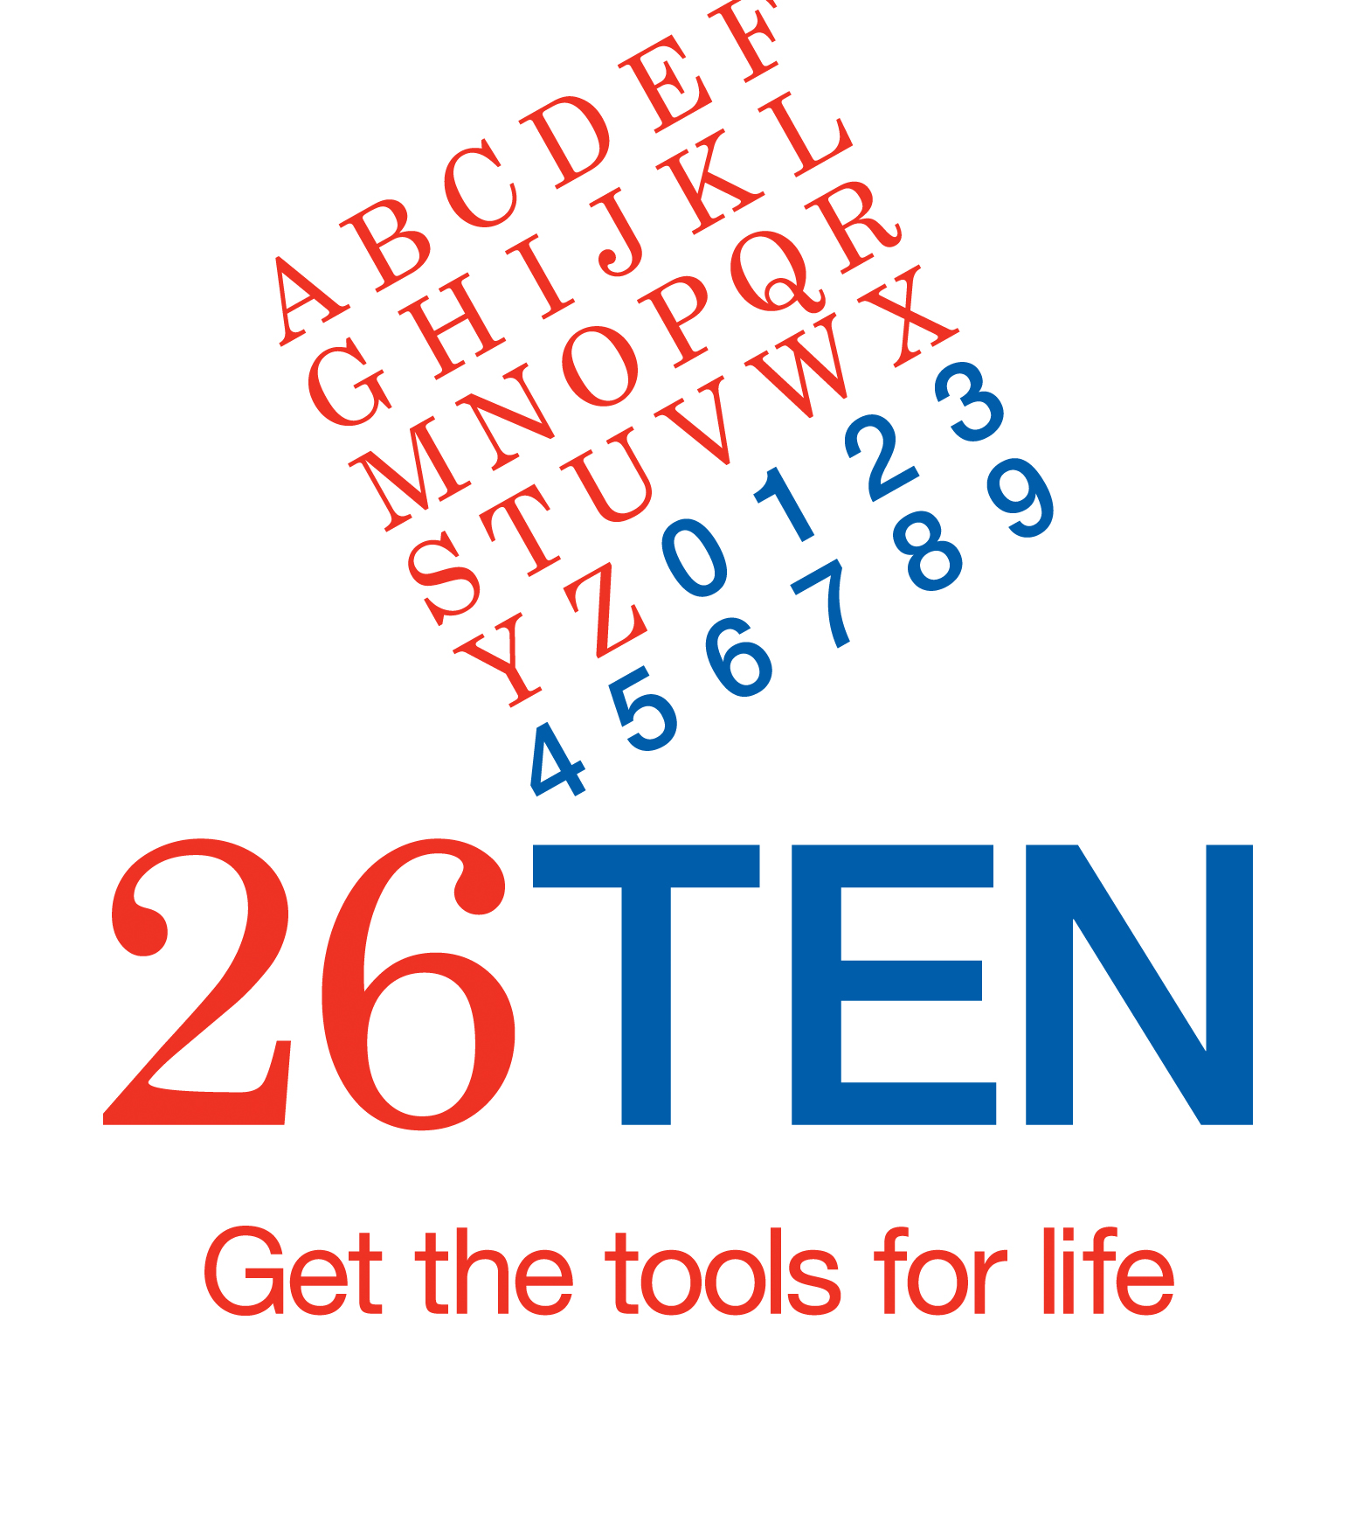

Thank you for your interest in becoming a member of the 26TEN Network.

The 26TEN Network brings together business, community and government organisations to raise awareness and help Tasmanians improve their literacy skills. With nearly one in two Tasmanians having difficulty with everyday literacy and numeracy tasks, every contribution makes a difference.

As a member of 26TEN you can develop a plan of action to promote 26TEN and/or to address your literacy needs. We have included a list of ideas to help you develop your plan, and encourage you to review it every six months.

Please complete and return the application for membership and your 26TEN Action Plan so that you can join us in our campaign on adult literacy in Tasmania. We would also like a high resolution image of your logo to include on our web page.

The 26TEN support team is happy to answer any questions you have. Contact us at email@26ten.tas.gov.au, phone 6165 5514 or find more information on the 26TEN website www.26TEN.tas.gov.au

Once again, thanks for your interest in joining us. We look forward to working with you.

Yours sincerely

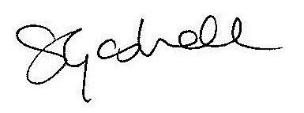

Siobhan Gaskell
Convenor 26TEN Coalition

26TEN Network: Application for membership
Name of organisation
Address
Postal address
Type of organisation | Government Business Community  Main purpose: _____________________________________  _________________________________________________
Contact person | Name
 | Position
 | Phone number
 | Mobile
 | Email
Is your action plan attached Do you have a Facebook page Is your logo attached

Name
Position
Signed and Date
Phone Number

Taking action – some ideas
We ask members to develop a plan of action to promote 26TEN and/or to address their literacy needs. Here are some ideas to help you develop your plan:
Promote adult literacy and numeracy
- Have 26TEN brochures and contact details available to staff and clients
- Hold a literacy awareness workshop for your staff and/or community
- Provide an article for the 26TEN newsletter about your activities
- Encourage other organisations to join 26TEN
- Promote 26TEN at your next professional/industry conference
- Add the 26TEN logo to your email address block
Support literacy skills
- Train your staff to identify when clients need help and how they can do this
- Support individuals (employees, clients, volunteers) to improve their own skills
- Support employees to become volunteer literacy tutors
- Support a specific 26TEN initiative
Communicate clearly
- Use plain English
- Analyse documents and brochures for clarity and rewrite as necessary
- Ask customers and clients to give you feedback on your public documents
- Include regular tips about plain English in your staff newsletter
- Talk about plain English at staff meetings
- Have examples of ‘before’ and ‘after’ documents for staff to discuss and learn from
- Include information about plain English in staff inductions
- Hold a 26TEN plain English workshop for your staff

26TEN Network Support

Members of the network can expect the following support:
- access to support and advice including literacy awareness raising workshops, and plain English workshops;
- promotion of 26TEN Members and related activities in media releases, newsletters, the 26TEN website and public reporting;
- listing of Member organisations on the 26TEN Members Register;
- events for members;
- access to local contacts in the business, community and Government sectors who are 26TEN Network members;

26TEN Network: Conditions of Membership
The organisation will:
- contribute to the improvement of adult literacy in Tasmania;
- use the 26TEN logo in accordance with the agreed protocols; (Attachment 1)
- be identified on the 26TEN website as a member of the 26TEN Network;
- provide information for inclusion on the 26TEN website and any other public communications;
- promote the 26TEN Network whenever possible; if this is through media releases and promotional material use the media protocol;
- consider and suggest ways we might work together in the future;
- review and report on the progress with the Action Plan, twice a year.

26TEN Action Plan 2016
Name of organisation:

Date:
Action 1
Action 2
Action 3

26TEN Action Plan Review <period>
Name of organisation: Date:
Progress
Action 1

Progress
Action 2

Progress
Action 3

Your key achievements that you are happy for us to share on the 26TEN website
(photos, good news stories, newsletter articles)
Lessons learned/barriers

How can 26TEN help? Would you like any of the following? | Plain English Workshop Literacy Awareness Workshop  Guide to Plain English 26TEN poster 26TEN decal 26TEN brochures

Attachment 1

USE OF 26TEN BRAND AND MEDIA PROMOTION

PROTOCOL
This protocol relates to the use of the 26TEN logo and the issuing of media releases by organisations that are members of the 26TEN Network.

LIABILITY
In using the logo any organisation, agency or body must agree:
- that the activities they carry out are in accordance with applicable laws;
- to take responsibility to ensure they have obtained appropriate insurance to cover the risks arising out of such activities;
- that 26TEN and the Tasmanian Government do not assume any responsibility for the activities of the member organisation;
- that the use of the logo by the member does not represent any form of endorsement and/or support of the member’s products or services by the Tasmanian Government or 26TEN; and

- that in any action brought as a result of the members use of the logo, the member will defend 26TEN and the Tasmanian Government and its officials against any action that may be brought against the 26TEN and the Tasmanian Government or its officials.

USE OF 26TEN LOGO
26TEN Network members are encouraged to use the 26TEN logo on internal and external documents including communications and information provided to staff, promotional material, stationery, newsletters, websites, signage and media releases. This is encouraged particularly where the activity/activities concerned directly relate to 26TEN goals.
All materials created to promote goods and services in association with the 26TEN logo must comply with the Standards of Use (see below).
Government departments using the 26TEN logo must also comply with the Tasmanian Government Style Guide and Logo Policy. Where used by Tasmanian Government departments, the 26TEN logo should always be treated as a graphical device in conjunction with the Tasmanian Government logo, and never as a replacement for it.
Non-government organisations should not use the Tasmanian Government logo without prior agreement from the relevant department.

26TEN Style Guide
The 26TEN Style Guide is the main authoritative source of information on use of the 26TEN brand and logo. A 26TEN Style Sheet is attached to this document (the full Style Guide is available on request) and logo files are also available for use.

Rules relating to design, colour and size
The design of the 26TEN logo cannot be altered under any circumstances. This means that members cannot make alterations to the graphic proportions of the logo or its individual elements. Specifications concerning size and colour variations are included in the Style Guide and on the Style Sheet.
Variations
26TEN Network members wishing to use the 26TEN logo and brand in a manner that does not conform to the 26TEN Style Guide or for a purpose that does not conform to the Standards of Use (see below) can submit a written request to the Brand Manager (email@26ten.tas.gov.au).
Applications may be submitted at any time. The Brand Manager will maintain a register containing all applications to vary the use of the 26TEN logo and relevant approvals.

MEDIA RELEASES ISSUED WITH THE 26TEN LOGO
26TEN Network members are encouraged to help promote 26TEN initiatives and good news stories through their own networks and to local media.
Prior to distributing a media release, where possible, the member should inform 26TEN by email (email@26ten.tas.gov.au) this will enable 26TEN to provide a supportive comment if considered appropriate, or for 26TEN to issue its own media release.
On issuing a 26TEN related media release, please email 26TEN a final copy on the day of release.
26TEN will contact its members prior to issuing a media release, if the release mentions a specific member name. Joint media releases may be issued from time to time, when it is considered appropriate by both organisations.
STANDARDS OF USE
Consumers who look for and access/purchase products and services promoted in association with the 26TEN logo are a key stakeholder in the 26TEN network. It is vital, therefore, that consumers are certain that the logo is being used according to consistently applied rules and conditions.
All 26TEN branding, advertising, marketing and promotions – whether issued by 26TEN or 26TEN Network members, will comply with the following standards:
- materials promote a positive and accessible view of 26TEN;
- materials communicate clearly in plain English and are appropriate for the target audience;
- materials do not make misleading or inaccurate claims or provide incorrect information;
- materials are legally compliant and non-discriminatory;
- materials promote a safe and healthy lifestyle;
- claims made are evidence-based;
- testimonials are genuine, verifiable and relevant;
- materials avoid the use of ”fine print” and enable clients to make an informed choice; and
- materials avoid using abbreviations.

For further information contact:
26TEN Brand Manager by email: email@26ten.tas.gov.au

